Project Report Template

**1 INTRODUCTION**

1.1 Overview

Administrator should be able to create all base data including Semester, Candidate, Course and Lecturer. Lecturer should have the ability to create Internal Results. Dean who is one of the Lecturer should have the ability to update Internal Results. Revaluation can be initialized by Candidate for all Internal Results. Now only dean can update the marks after re-evaluation.

1.2 Purpose

This project can be widely used in schools and colleges as it provides result tracking more precise and accurate. It is highly secured as the dean is able to change the marks after revaluation. So the institution can make use of this project as it will provide best tracking.

1. **Problem Definition & Design Thinking**

2.1 Empathy Map

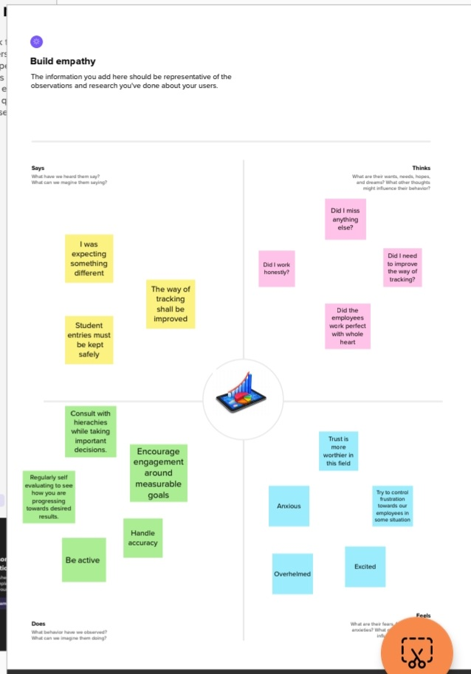

2.2 Ideation & Brainstorming Map

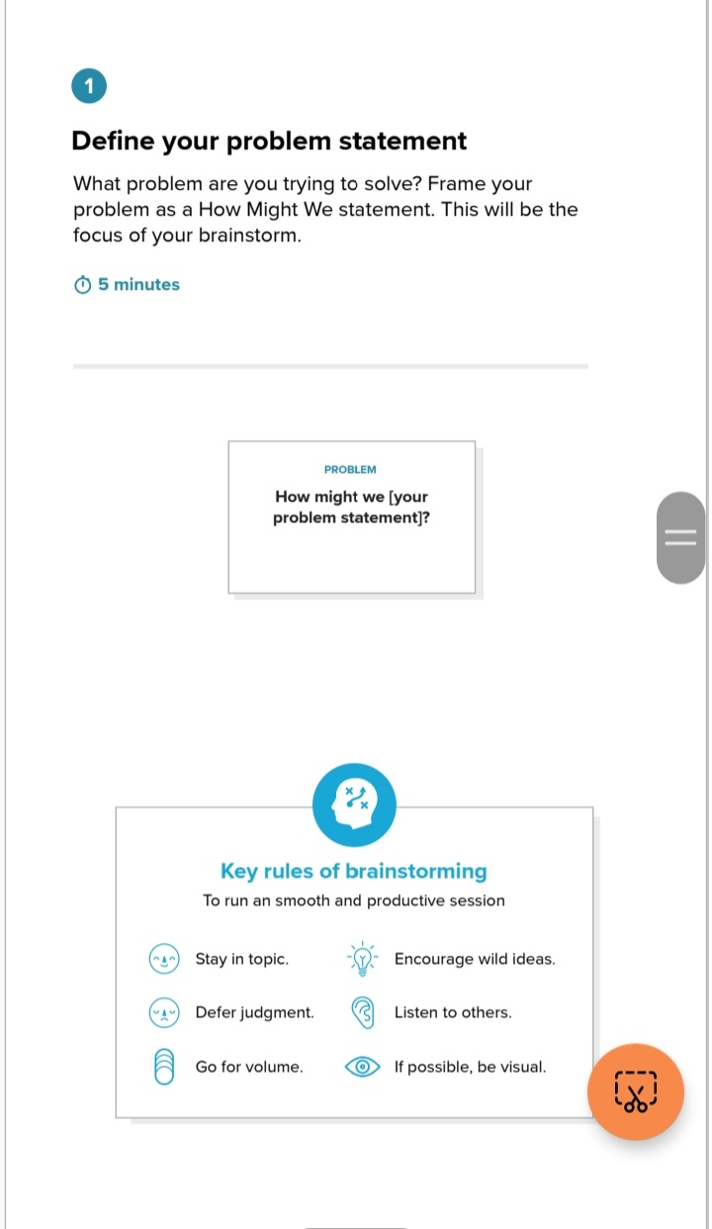

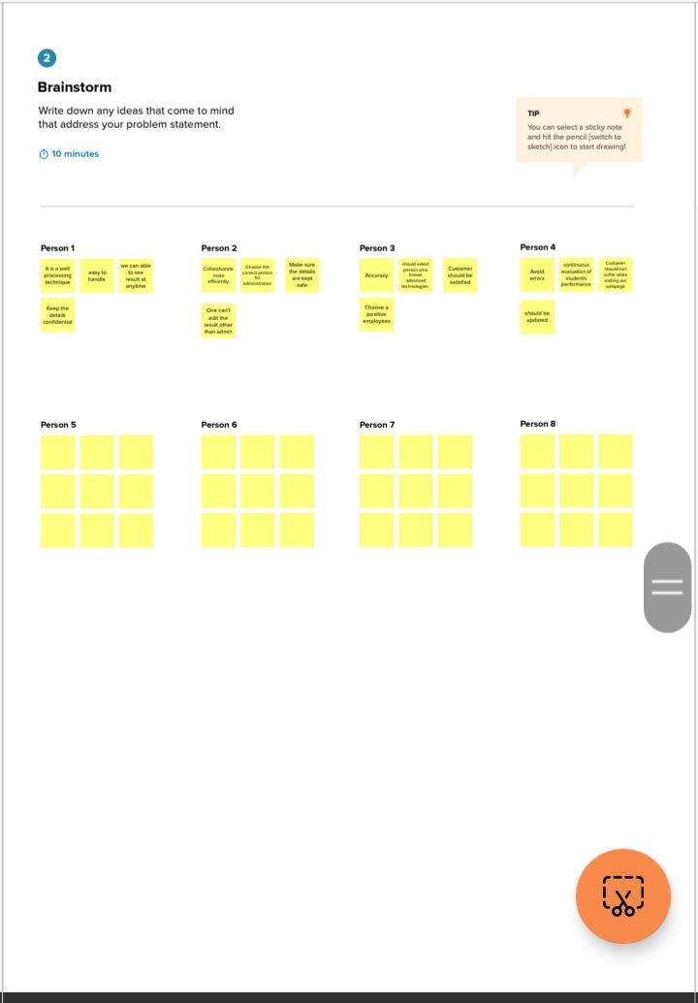

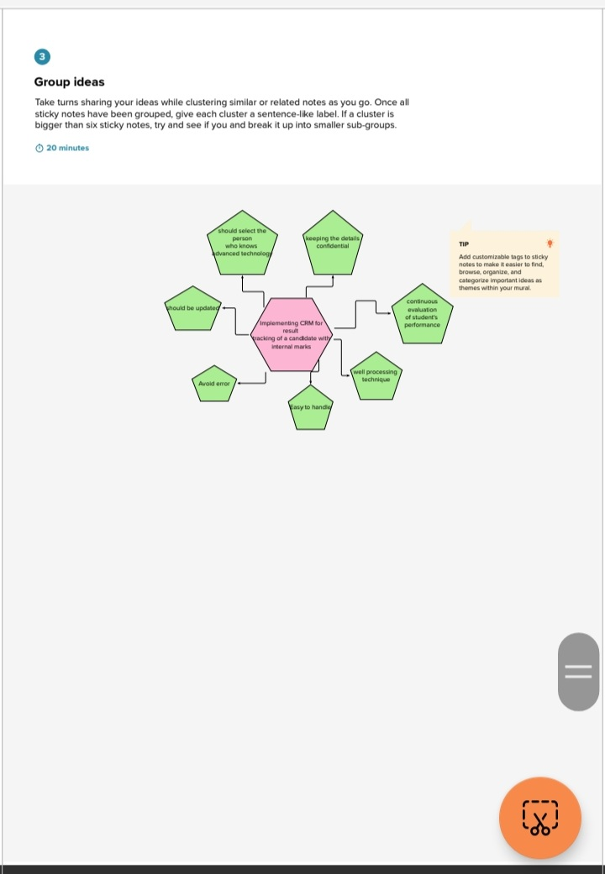

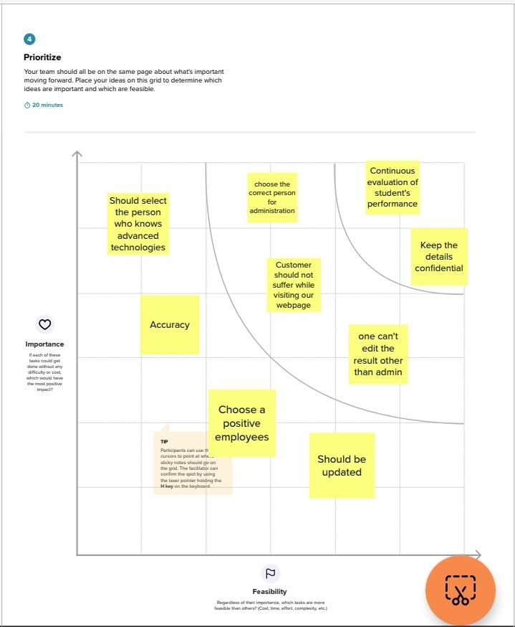

**RESULT**

3.1 Data Model:

|  |  |
| --- | --- |
| **Object Name** | **FIELDS IN THE OBJECT** |
| Semester | |  |  | | --- | --- | | Field Label | Data Type | | Semester Name | Text | | Course | Lookup | |
| Candidate | |  |  | | --- | --- | | Field Label | Data Type | | Candidate Name | Text | | Candidate Id | Number | | Semester Name | Text | | Internal Result | Lookup | |
| Course Details | |  |  | | --- | --- | | Field Label | Data Type | | Course Name | Text | | Course Id | Number | |
| Lecturer Details | |  |  | | --- | --- | | Field Label | Data Type | | Lecturer Role | Text | | Lecturer Name | Text | | Course Id | Number | | Course | Lookup | |
| Internal Result | |  |  | | --- | --- | | Field Label | Data Type | | Candidate ID | Number | | Course Id | Number | | Marks | Number | |

**3.2 Activity & Screenshot**

To create an object first login to salesforce and click on gear icon and then setup then click object manager tab beside home tab then select custom objects.

For eg for semester we should create the object as shown below

Label:Semester

Plural Label: Semesters

Record Name: Semester Name

Check allow report and allow search checkbox. Now save. Similarly create the custom objects candidate, course detail, lecturer detail and internal result as follows.

Next we have create custom tab for custom objects. First click on Tab click new for object click semester and choose any icon on your wish and save. Similarly create all custom tab for all objects.

Field and Relationship:

To create field and relationship go to setup anf click object manager beside home tab and click on Semester. Then select Fields and Relationship just on the left side and click on New and create then select the data type as suitable for the object and after that fill field label given (Semester Name) then click next and save.

Similarly create fields with suitable data type from the custom objects. Then save.

Lighting App:

From Quick Find Box select App Manager and click on new lighting App then enter Candidate with Result Card as a App Name then click next from available items select Semester, Candidate, Course details, Lecturer Details and Internal result to the selected item by clicking right arrow. For Available profiles select System Administrator. Click save.

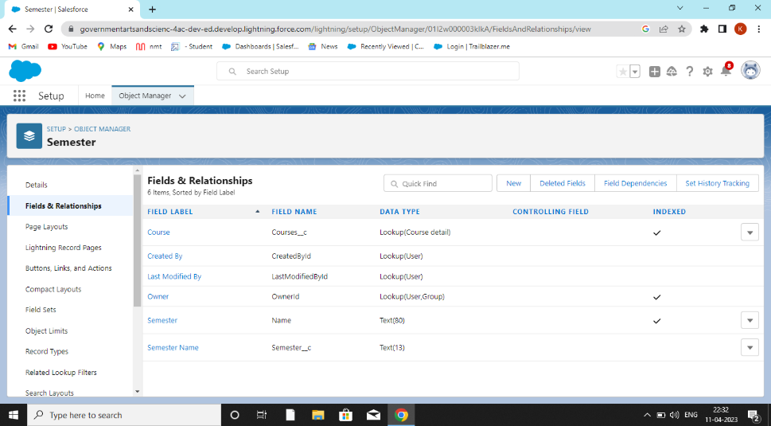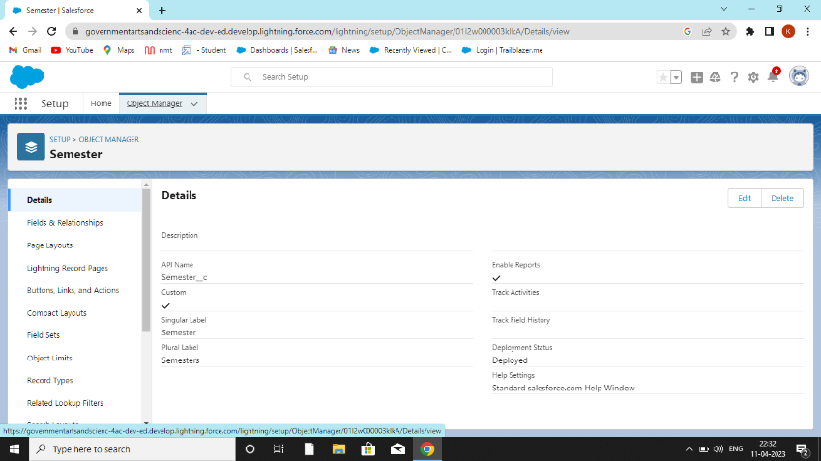

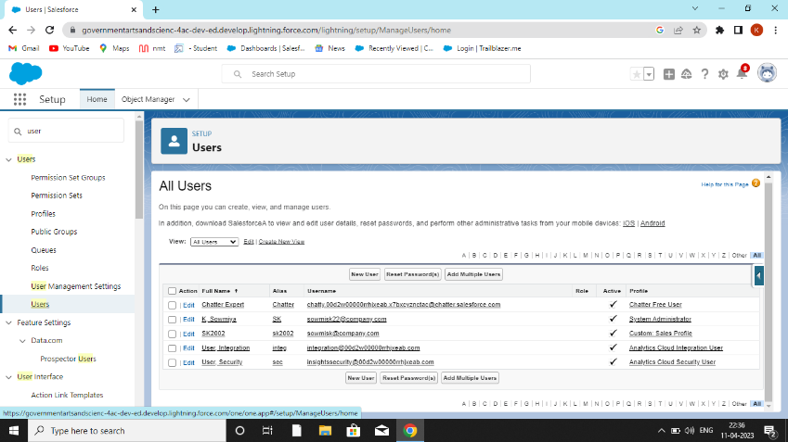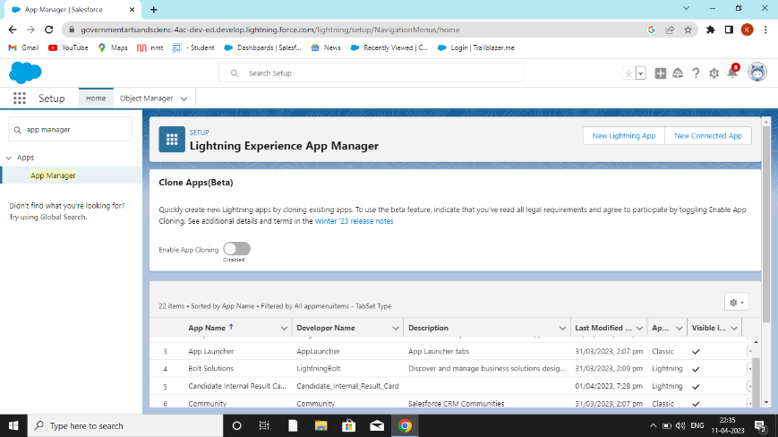

User:

Select User from Quick find box then click on new user then give username, email address and all the details. Then select none on role and profile as salesforce user.

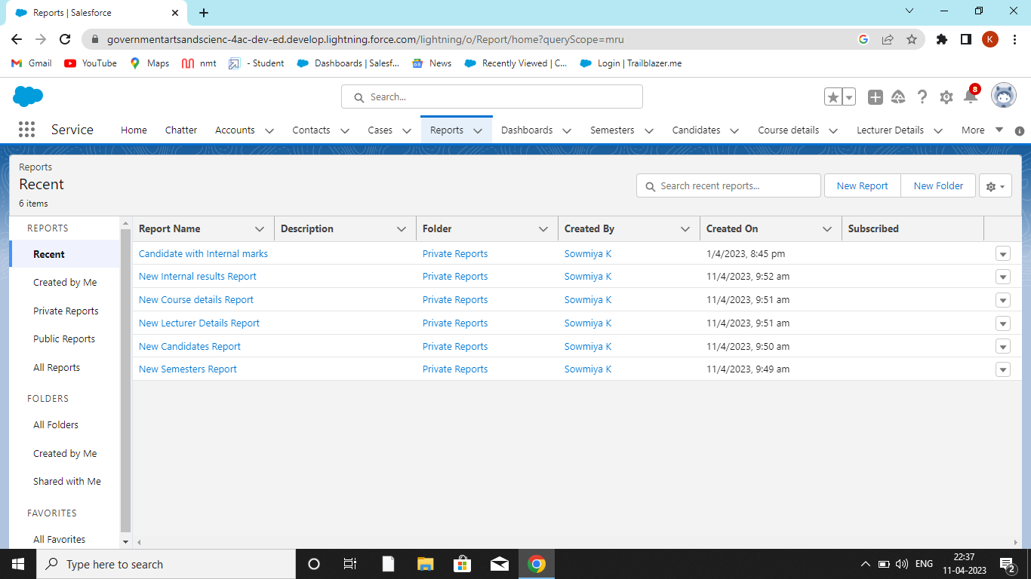Reports: From Report click New Report then enter Candidate with internal marks for report and create and start report. Similarly create a new report for each of the custom object and save or run it.

At last we get a reports as shown in the screenshot.

Dashboard:

Click on App Launcher. Then go to service as before and select Dashboard. Click on new dashboard then name the dashboard as candidate board. Click + component and for report select the reports which have created already in the above process. Click them one by one. Then we should enter some data then only we can select vertical bar chart. For that go to App Launcher go to Candidate with Result Card App which we have created. Then custom object will visible above click one by one and give details on your wish and finally you get a page as shown below.

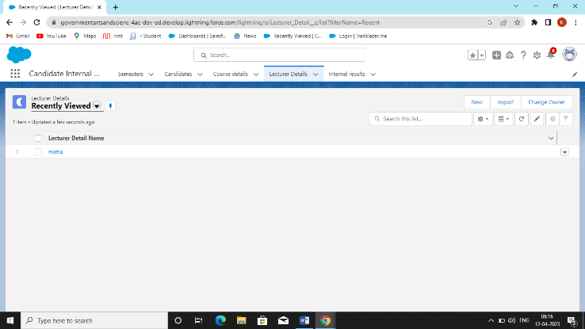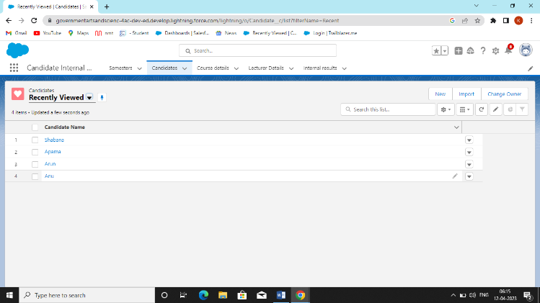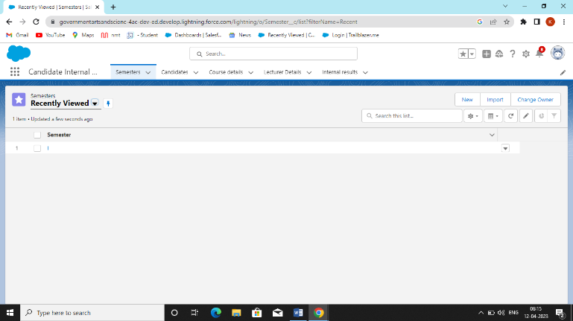

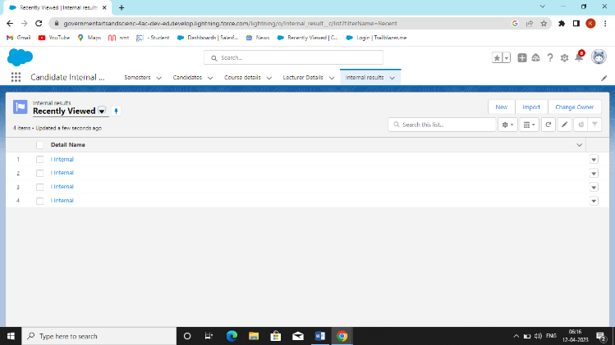

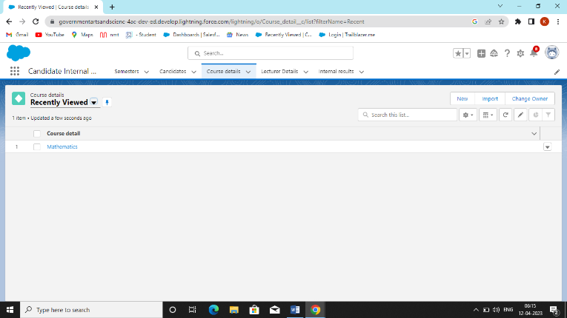After completing go to dashboard click on Candidate with internal mark dashboard then we can see all the details given and add vertical bar chart. The final outcome is shown below.

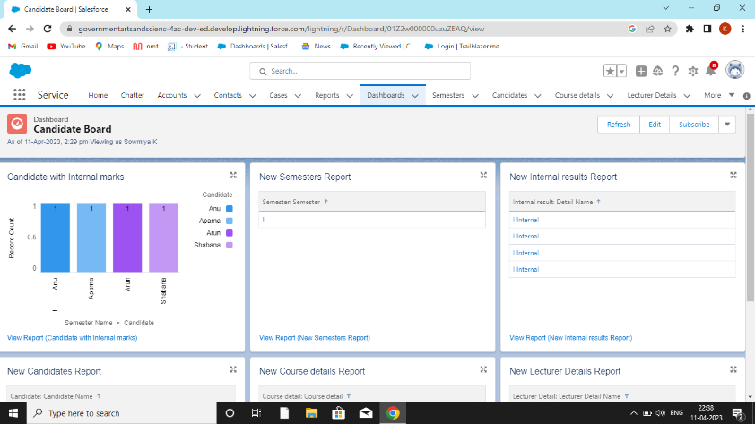

**4 Trailhead Profile Public URL**

**Team Lead :** <https://trailblazer.me/id/keerm32>

**Team Member 1:** <https://trailblazer.me/id/ksowmiya1>

**Team Member 2:** <https://trailblazer.me/id/sebithajothia7>

**Team Member 3:** <https://trailblazer.me/id/kirub>

**5 ADVANTAGES & DISADVANTGES:**

Candidates tracking system advantages include enabling you to focus more on tasks that truly require your attention rather than spending manual resources on routine, tasks. Well tracking system can save almost 50% of your time by automating these routine tasks. In doing so, your processes get more efficient and faster. It is highly secured and very confidential. Tracking are well organized as it will determine the student future career.

There is a limited disadvantage in this project. With human error student marks are entered wrong and this may result in the revaluation. And the other thing is error in web page. This will happen often during the result day.

**6 APPLICATIONS:**

This application can track all the communication with candidates. This makes it easy to search and filter resumes and other candidate information, decreasing time to fill and ensuring the companies get the best candidate for the positions.

**7 CONCLUSION:**

It is essential to simplifying and automating your recruitment process and help you become more efficient and effective in your day-to day tasks. They also play a part in enhancing your candidate experience, decreasing your workload, and improving your hiring results.

**8 FUTURE SCOPE**

Leaving tradition behind, the recruitment technology domain has added new aspects and innovative features, making the core of the recruitment industry. It has embraced multiple processes of accessing and distributing in genres like social networking via Whatsapp and video conferencing.